
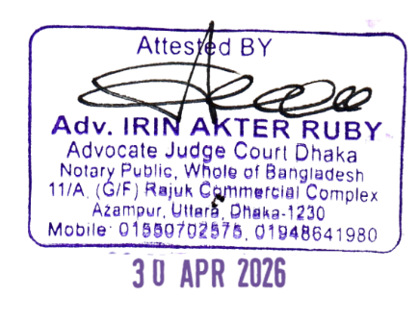
(Translated True Copy)
Government of the People’s Republic of Bangladesh
NATIONAL ID CARD

Name : MST ALEYA PERVIN
Father: Abdus salam
Mother: Jarina khatun
Date of Birth: 18 Sep 1980
NID NO: 147 055 5887
Photograph
Monogram
18 Sep 1980
Photograph

SIM Card
Sd/- Illegible

Address: Village/Road: Chondrokona Pashcim, Munsumi, Post Office: Sirajganj-6700, Sirajganj Sadar, Sarajganj

Blood Group: Place of Birth: SIRAJGANJ Date of Issue: 25 Jan 2018

I<BGD147055588<72<<<<<<<<<<<<<
8009180F3301247BGD<<<<<<<<<<<2
PERVIN<<MST<ALEYA<<<<<<<<<<
Photograph
Monogram

